Update N4T/N4B Job Groups

1. Before update/delete job groups, you need to consider how many job groups need in new environments and the nodes assignment (also need to standardize the cluster node name in advanced).

**N4T**



3.8 New Job Groups & Nodes

|  |  |  |  |
| --- | --- | --- | --- |
| Env | New Job Group ID & Nodes | New Job Group Description | Balancing Scheme |
| DEV |  |  |  |
|  |  |  |
|  |  |  |
| SIT |  |  |  |
|  |  |  |
|  |  |  |
| UAT | AppGroup1 | APP1 & APP2 | Assign jobs randomly within the group |
| app1  app2 | |  |
| EdiGroup1 | APP3 & EDI1 | Assign jobs randomly within the group |
| app3  edi1 | |  |
| GateGroup1 | APP4 & GATE1 | Assign jobs randomly within the group |
| app4  gate1 | |  |
| SIM |  |  |  |
|  |  |  |
|  |  |  |
| GOLDEN |  |  |  |
|  |  |  |
|  |  |  |

2.6 to 3.8 Job Group Default Mapping

|  |  |  |  |  |  |
| --- | --- | --- | --- | --- | --- |
| 2.6 PROD Job Group | Map to 3.8 New Job Group | | | | |
| DEV | SIT | UAT | SIM | GOLDEN |
| APP SRV1 |  |  | AppGroup1 |  |  |
| APP SRV2 |  |  | AppGroup1 |  |  |
| APP SRV3 |  |  | EdiGroup1 |  |  |
| APP SRV4 |  |  | GateGroup1 |  |  |
| APP SRV5 |  |  | GateGroup1 |  |  |
| EDI SRV1 |  |  | EdiGroup1 |  |  |
| EDI SRV2 |  |  | AppGroup1 |  |  |
| GHS SRV1 |  |  | GateGroup1 |  |  |
| GHS SRV2 |  |  | GateGroup1 |  |  |



**N4B**

3.8 New Job Groups & Nodes

|  |  |  |  |
| --- | --- | --- | --- |
| Env | New Job Group ID & Nodes | New Job Group Description | Balancing Scheme |
| DEV |  |  |  |
|  |  |  |
|  |  |  |
| SIT |  |  |  |
|  |  |  |
|  |  |  |
| UAT | AppGroup1 | BILLING 1 | Null |
| Billing1 | | Null |
| AppGroup2 | BILLING 2 | Null |
| Billing2 | |  |
| SIM |  |  |  |
|  |  |  |
|  |  |  |
| GOLDEN |  |  |  |
|  |  |  |
|  |  |  |

2.6 to 3.8 Job Group Default Mapping

|  |  |  |  |  |  |
| --- | --- | --- | --- | --- | --- |
| 2.6 PROD Job Group | Map to 3.8 New Job Group | | | | |
| DEV | SIT | UAT | SIM | GOLDEN |
| APP SERVER 1 |  |  | AppGroup1 |  |  |
| APP SERVER 2 |  |  | AppGroup2 |  |  |

1. Execute below script to get and mark down the default job groups, when relaunch default jobs, you can refer to it.

|  |
| --- |
| select job_name, sched_name  from navisusr.QRTZ_JOB_DETAILS  where job_group = 'DEFAULT'  order by sched_name;  select job_name, sched_name  from navisbill.QRTZ_JOB_DETAILS  where job_group = 'DEFAULT'  order by sched_name; |

|  |  |
| --- | --- |
| **N4T (Sample):** | **N4B (Sample):** |

1. Startup all N4 3.8 cluster nodes and verify them all active via cluster service.
2. Update below SQL scripts with the above job group design for different environment and execute it with DB system account to patch the job groups.

|  |  |  |  |  |
| --- | --- | --- | --- | --- |
| DEV | SIT | UAT | SIM | GOLDEN |
|  |  |  |  |  |

1. Login to N4T and N4B app server 1 respectively, and **GU** as below.







1. Double check all job groups status.

if someone status is shown down, take N4B as an example,

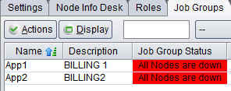

* 1. check cluster services status in DB.

select * from frm_cluster_service;

* 1. if the target N4B service is up but shown “Disconnected” in DB, and the active ones are not supposed, please delete the active services, and update status of target N4B services to “Active”.

1. delete frm_cluster_service where clservice_ip_address like '172.25.35%';
2. update frm_cluster_service set clservice_status = 'ACTIVE' WHERE clservice_ip_address like '172.25.48%';

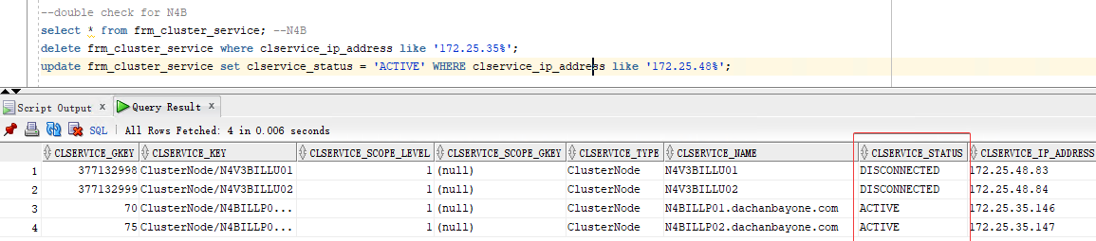

* 1. Reboot N4B service